**Content**

1. Nadpis 1 3

1. Introduction

*Unix/Linux Shell is a command line interpreter which interacts with kernel on the user’s behalf. Interaction with the shell help in inter*

The Kernel does not understand most of the stuff, but system call. What a shell does is take the input from the user, make it the way the Kernel does understand.

1. C-Shell: tcsh, csh (partly understands the C-type syntax, competely different)
2. Bourne shell: sh, bash,ksh, pdsh

/etc/passwd

root:x:0:0:root:/root:/bin/bash

username:password required: userID: group ID: Description: Home directory: Shell to be used.

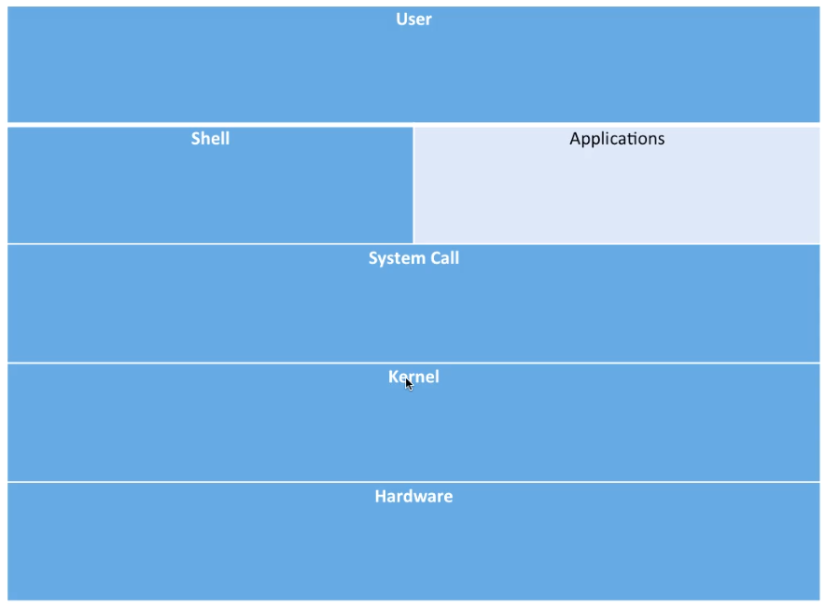

Kernel is the heart of any OS. In case of OS like Ubuntu/Fedora/CentOS the kernel is Linux. The kernel manages sarious hardware resources in the system like, CPU, memory, disk, display, serial port, Network, Different type of Ios and almost everything which is physically present. Without the kernel an OS cannot be envisioned.

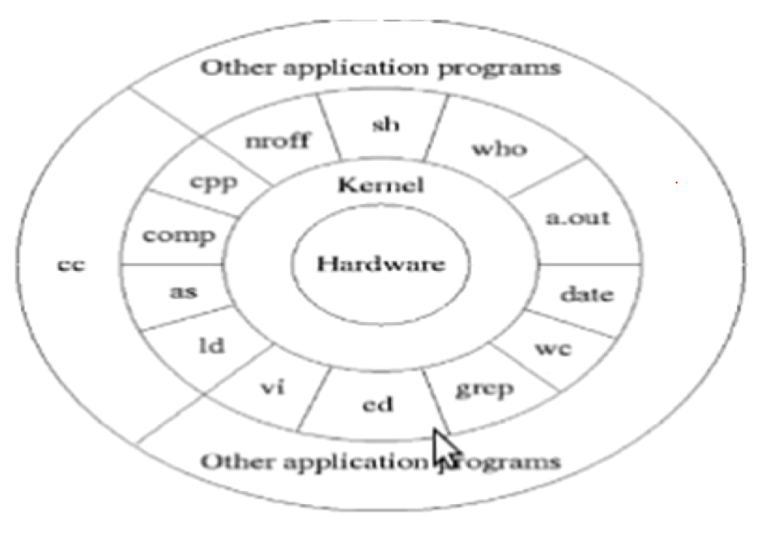

|  |  |
| --- | --- |
| / | root |
| /bin | Contains the system Binaries |
| /home | User’s home directory |
| /dev | Device files like block and character devices |
| /etc | System Configuration |
| /lib | Shared library and kernel modules |
| /lib64 | Contains 64-bit version shared library |
| /var | Data which varies over time – e.g. mysql, logs |
| /sbin | Binary utilities for which only root has access |
| /mnt | Mount point for filesystem |
| /tmp | Used for storing temporary data and files |
| /proc | Kernel data structure mounted as filesystem. Only aplplicable to Linux based OS. |
| /boot | Contains the initramfs and kernel image |
| /sys | Kernel data structure for different hardware and device like Block Device, Firmware, ACPI .. Applicable for Linux based OS only. |
| /usr | User programs |
| /opt | Optional add-on apps |
| /media | Removable devices |

Multi-Tasking OS means that multiple processes (Task, threads or programs ) can run in the system simultaneously. CPU and memory are shared. Each process is scheduled for a short period of time based on Round robin or FIFO.

Multi-User – multiple user can log in simultaneously using remote terminal or ssh or Telnet and they can each run their own copy of same programs of different programs without interfering with each other.

Multi-core (SMP) Symmetric Multi-Processing

Semaphors?